In the heart of Broadwell, local democracy beats strong as the community and council approach another financial year. This is not just an event; it's an opportunity for residents to actively shape the future of their beloved parish. Remember, the democratic process is the cornerstone of any thriving community, and Broadwell is no exception.

The strength of any democratic system lies in the diversity and representation of its leaders. Broadwell Parish Council currently seeks three individuals who are passionate about community welfare, keen on making a positive impact, and dedicated to fostering growth. As an elector, you can play a crucial role in identifying potential councillors. Who do you know that embodies the values and aspirations that reflect the spirit of Broadwell? The Parish Council invite you to nominate those individuals who you believe have the drive to contribute and principals to nurture improvements in the community of Broadwell.
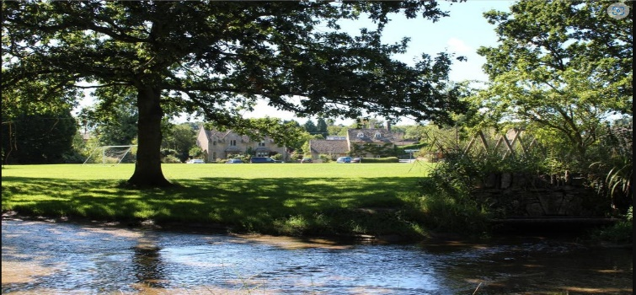

Broadwell Village

Nominating a councillor is a straightforward yet
powerful way to participate in the democratic process.

Every elector has the right to propose individuals they believe would be effective councillors. This is an inclusive process, ensuring that diverse voices are heard and considered. The more varied the pool of candidates, the richer the representation, and the more complete the solutions to the local challenges facing Broadwell.

While enthusiasm and dedication are essential, candidates must also meet certain criteria to be eligible for the role of councillor. The criteria can be found on the government website at this link Become a councillor - GOV.UK (www.gov.uk) or alternatively you can email the clerk at Broadwell Parish Council clerk@broadwellpc.org for further information.

Broadwell Parish Council welcomes and values a mix of social standings, skills, experiences, and perspectives. Understanding local issues, having a vision for the future, and possessing the ability to work closely in a team, are key attributes. It's not just about having the desire to lead but also about having the capacity to listen, learn, and act in the best interest of the community.

The true power of democracy lies in the hands of you the voters. As an active member of the Broadwell community, your vote is your voice. You can contribute to the selection of councillors who will be the voice of the people in your community. These elected representatives will champion the interests and concerns that matter most to you. When the time comes, encourage your neighbours, friends, and family to exercise their right to vote at elections or to stand now as a councillor, ensuring that Broadwell Parish Council truly reflects the will of the people.

Broadwell Parish Council members are not just a bureaucratic group or process; they are an indication of the spirit that binds us together as a community. By identifying potential councillors, participating in the nomination process, and casting your vote, you become an active spokesperson of Broadwell's future. Embrace the democratic process, and let your voice resonate in the shaping of a vibrant and prosperous community.

